**TE MINI-PROJECT REPORT ON**

**“HOUSE PRICE PREDICTION”**

Submitted in fulfillment of the requirement of University of Mumbai For the degree of

#### Bachelor of Engineering (Information Technology)

By

#### Tejas Kolhe TU4F1920039 Rushikesh Bandiwadekar TU4F1920040 Sanika Pharande TU4F1920053 Pranav Bulbule TU4F1920031

Under the Guidance of

#### Prof Shyamsundar Magar



**Department of Information Technology Engineering**

## TERNA ENGINEERING COLLEGE UNIVERSITY OF MUMBAI

**FH-2022(2021-2022)**

**CERTIFICATE**

This is to certify that the project entitled “**House Price Prediction**” is a bonafide work of **“Tejas Kolhe” (TU4F1920039), “Rushikesh Bandiwadekar” (TU4F1920040) “Sanika Pharande” (TU4F1920053), “Pranav Bulbule” (TU4F1920031)** submitted to the University of Mumbai in partial fulfilment of the requirement for the award of the degree of “**Bachelor of Engineering**” in “**Information Technology**”

(Prof. Shyamsundar Magar) (Prof. Praveen Shinde)

Supervisor/Guide Project Coordinator

(Dr. Vaishali Khairnar) (Dr. L.K. Ragha)

Head of Department (IT) Principal

**Acknowledgement**

No project is ever complete without the guidance of those expert who have already traded this past before and hence become master of it and as a result, our leader.

So we would like to take this opportunity to take all those inviduals how have helped us in visualizing this project.

We express our deep gratitude to our project guide **Prof. Shyamsundar Magar** for providing timely assistant to our query and guidance that she gave owing to her experience in this field for past many year. She had indeed been a lighthouse for us in this journey.

We would also take this opportunity to thank our project co-ordinate **Prof. Praveen Shinde** for his guidance in selecting this project and also for providing us all this details on proper presentation of this project.

We extend our sincerity appreciation to all our Professor form Terna Engineering College for their valuable inside and tip during the designing of the project.

Their contributions have been valuable in so many ways that we find it difficult to acknowledge of them individual.

We also great full to our HOD **Dr. Vaishali Khairnar**, Principal **Dr.L. K. Ragha** for extending their help directly and indirectly through various channel in our project work.

**Abstract**

Property is a clear industry in our ecosystem. Housing prices continue to fluctuate from day to day and are sometimes raised based on calculations. Assuming real estate prices by actual factors is core of our project. We aim to do estimation base on all the underlying common parameters considered when analyzing the value. We use a variety of regression strategies in our project, and our results aren’t only a one-size-fits-all approach but also a weighty approach of different strategies to deliver the most precise results. The results proved that this method produces less error and higher accuracy than the single algorithm used.

The acquisition of a house based on the desirable features of the real estate price model is modeled on the proposed work and the model is designed for the city, Nerul.

**INDEX**

|  |  |
| --- | --- |
| Content | Page no |
| Abstract |  |
| 1. Introduction | **1** |
| 1. Literature Survey | **2** |
| 1. Problem Statement | **6** |
| 1. Proposed System | **7** |
| 1. Implementation | **9** |
| 1. Conclusion and Future Scope | **10** |
| Reference |  |

|  |  |  |
| --- | --- | --- |
| Sr. No | List of Figures | Page No. |
|  |  |  |
| 1 | Fig. 4.1 – Block Diagram  Fig. 4.2 – Flow Chart | **7** |
| 2 | Fig. 5.1 – Blank GUI | **7** |
| 3 | Fig. 5.2 – Predicted Price | 9 |

**Index of figures**

9

4

**Chapter - 1**

### Introduction

#### Scope

#### Predicting House Price, it is important to drive the effectiveness of Real Estate. As before, house prices were determined by calculating the acquisition and sale value in the area. Therefore, the Real Estate Price model is very important in filling the information gap and improving the efficiency of Real Estate

#### Motivation

#### Predicting home prices are expected to help people who plan to buy a home so that they know the price level in the future, and then be able to plan their finances better. In addition, real estate forecasts are also useful for real estate investors to be aware of real estate prices in a given area. The relationship among housing prices and the economy is motivating factor in predicting house prices. Real estate prices not only annoy buyers and sellers, but also reflect economic conditions.

#### Objectives

#### As a first project, we aimed to make it as informative as possible by going through each phase of the machine learning process and trying to understand it well. We have chosen the Nerul Real Estate Prediction as a method, known as the "play story," which identifies problems that are not immediately related to science but are useful for demonstrations and practice. The aim was to predict the price of a particular apartment based on market prices while calculating the various "features" that would be established in the next phases.

**Chapter - 2**

### Literature Survey

|  |  |  |  |  |  |
| --- | --- | --- | --- | --- | --- |
| **Paper**  **No.** | **Publication & year** | **Title** | **Technologies**  **Used** | **Features and Advantages** | **Drawbacks** |
| **1** | IEEE 2019 | House Resale Price Prediction Using Classification Algorithms | ML Techniques. | Efficient price of real estate customer according to the  priorities and the  budgets must be predicted. This project efficiently analyzes past industry trends and price ranges to predict future prices. | Difficult to maintain monetary stability. |
| **2** |  | Housing prices prediction with deep learning | ML,  Python | The purpose of the current study was to predict house price based on in-depth learning algo. | The scale of features is different. Thus, the feature with  highest value will dominate and lessen the impact of the lower value feature. |

|  |  |  |  |  |  |
| --- | --- | --- | --- | --- | --- |
| **3** | IEEE 2019 | House Price Prediction | Linear regression and ANN | It can read and store a large no. of outline mode maps and does not need to display statistical map relationships. | This study will not cover the entire regression algo but will focus on the selected algo |
| **4** | IEEE 2021 | Informed Machine Learning | ML, Learning Algo, Final Hypothesis. | They present an overview of various approaches in house price prediction. They provide and suggest the concept of ML with info that shows their building blocks and distinguishes it from conventional ML. | Problems can be typically formulated as regression tasks where inputs X have to be map to outputs Y. |

|  |  |  |  |  |  |  |
| --- | --- | --- | --- | --- | --- | --- |
|  |  | IEEE 2020  **5** | Prediction of House Price Based on The Back Propagation Neural Network in The ‘Keras’ Deep Learning Framework | The Back Propagation Neural Network in ‘Keras’ Deep Learning Framework | It can read and save a large number of outline mode maps and does not need to display mathematical relationship map statistics. | This paper selects 12 major factors that have a significant impact on housing prices in Shanghai, and establishes a 6-level BP neural network based on the in-depth 'Keras' reading framework. |
|  | **6** | IEEE 2020 | House Price Prediction Approach based on Deep Learning and ARIMA Model | Deep Learning and ARIMA Model | The ARIMA model is a method for time series prediction. Assume that the historical values ​​of the series and the previous error terms also contain information for prediction. | The ARMA model is used for time series that is stationary. However, most of the original time series do not satisfy this condition. |
|  | **7** | IEEE 2021 | Deep Learning Model for House Price Prediction Using Heterogeneous Data Analysis Along With Joint Self-Atention Mechanism | Google Satellite Maps,  Spatial Converter Network, Shared Attention Mechanism | The model is used to automatically assign weights when the transaction data is given. | It should be improved to represent specific features more precisely. |

|  |  |  |  |  |  |
| --- | --- | --- | --- | --- | --- |
| **8** | IEEE 2020 | ML based Predicting House Prices  using Regression Techniques | Lasso regression, ridge regression,  regression methods | Modeling explorations apply some regression techniques such as  multiple linear regression (Least Squares), Lasso and Ridge regression models, support vector regression, and also boosting  algorithms such as Extreme Gradient Boost Regression (XG  Boost) | To improve accuracy of predictions it need to use advanced techniques of data mining. |
| **10**  **9** | IEEE 2018 | Real Estate Value Prediction Using Linear  Regression Techniques | ML, Linear Regression,  MSE,   RMSE | It is use to predict the resident prices  considering the financial plans and needs. By breaking down the  past market patterns and the value ranges of, and coming advancements  future costs will be anticipated. | The system is complicated(non- interactive). |
|  | IJERT 2021 | Real Estate Price Prediction | Machine Learning, Random Forest Regression, DT Regression. | The proposed system uses ML and AI techniques to develop algorithms that can be used to predict house prices based on specific inputs. | Less interpretable than decision tree. |

**Chapter - 3**

**Problem Statement**

In India, there are many websites that are categorized by real estate where buildings are listed for sale / purchase / rental purposes. But, there are lot of controversies of these websites about the price of the apartment and there are some cases where the same houses have a different price and as a result there is a lot of openness. Sometimes buyers may feel that  price is not appropriate for a particular apartment listed but there is no way to guarantee that.

  The problem with real estate forecasting is quite old and there are many studies and competitions dealing with similarities that includes, the old Boston housing price challenge in Kaggle. The problem statement was to predict the price of housing in Nerul on the given 9 factors like location type , availability, location, price, size, community, total square foot, no. of bathrooms and bedrooms.

### Proposed Methodology

**Chapter - 4**

### The core of our system consists of various essential aspects & data mining. Our first step was to clean up our database and reduce foreign prices. In addition, based on each parameter importance in determining the price of the system, the amount of each parameter was increased.

### 4.1 Algorithms used

### Linear Regression

Our data set contains various important aspects(parameter) & data mining is the root of our system. First, we cleaned the entire database and reduced foreign prices. In addition, we rated each parameter based on its value in determining the price of the system and this led to an increase in the amount of each parameter on the system. These regression values ​​are used to define the relationship between one dependent variable and one or more dependent variables. Single-dependent retrospective calculations and single independent variables are defined in the formula . b = y + x * a where, b = dependent variable points, y = always, x = coefficient of regression, and = independent variable points.

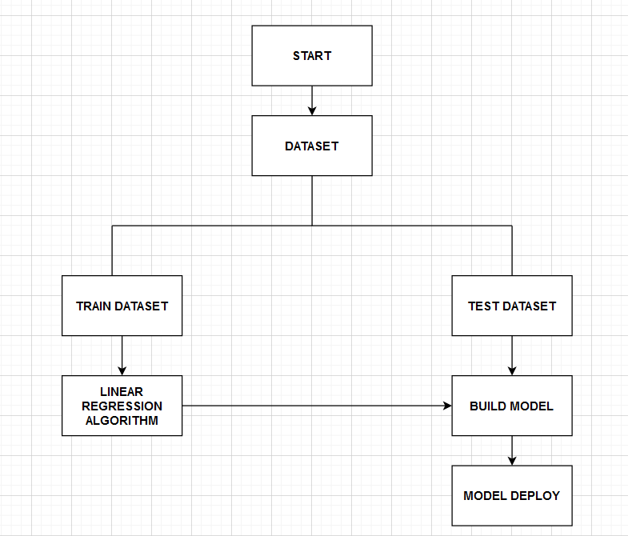

**Figure 4.1** – Block Diagram of House Price Prediction Model

# 

**Figure 4.1** – Flow Chart of House Price Prediction Model

# Implementation

**Chapter - 5**

# 

# Figure 5.1 - The blank GUI without values

# 

# Figure 5.2 - Price Predicted After inserting values

### Conclusion

**Chapter - 6**

This will help the customer to get all the daily necessities in the same place at an affordable price. Since the emergence of the growth of local platforms, this research has also produced outstanding service features in each service segment to enhance the quality of transportation services, offline local retailers and service providers with a new life for their business. These findings have significant implications for transport managers in designing services that take into account customer-centered voice services features. In Many of the research papers which we have studied

The accuracy after applying different algorithm was around 75-80%. But Our system Give the Accuracy of 86%.

**5.1 Future Scope**

System accuracy can be improved. A few additional quotes can be added to the system if the size and integration capacity increase in the system. In addition, we can integrate the UI / UX operating system to get the best results in terms of collaboration using Augmented Reality. Also, a learning program can be created that will gather user feedback and history so that the system can show the most relevant results for the user according to their preferences

### REFERENCES

[1] “Household Income and Expenditure Survey”, Statistics Korea, 2013.

[2] Anckar, B., P. Walden, and T. Jelassi, “Creating Customer Value in Online Grocery Shopping”, International Journal of Retail & Distribution Management, 30, 4, 2002, pp. 211-220.

[3]Bhattarai, A. (2020). ‘It feels like a war zone’: As more of them die, grocery workers increasingly fear showing up at work. Washington Post. Retrieved June 24, 2020, Retrieved from: https://[www.washingtonpost.com/business/2020/04/12/grocery-](http://www.washingtonpost.com/business/2020/04/12/grocery-) worker-fear-deathcoronavirus/

[4]Centers for Disease Control and Prevention. (2020). Coronavirus disease 2019 (COVID-19) Daily life & coping, Errands & going out running essential errands, Grocery shopping, take-out, banking, and getting gas. CDC.gov. Retrieved June 24, 2020, Retrieved from:[https://www.cdc.gov/coronavirus/2019-ncov/daily-life-](https://www.cdc.gov/coronavirus/2019-ncov/daily-life-coping/essential-goods-services.html) [coping/essential-goods-services.html](https://www.cdc.gov/coronavirus/2019-ncov/daily-life-coping/essential-goods-services.html)

[5] Everett, R. (2020). See how much we are now spending on groceries. NJ.com. Retrieved June 24, 2020, Retrieved from: [https://www.nj.com/coronavirus/2020/05/were-spending-more-](https://www.nj.com/coronavirus/2020/05/were-spending-more-ongroceries-and-learning-how-to-meal-plan-but-whats-the-new-normal.html) [ongroceries-and-learning-how-to-meal-plan-but-whats-the-new-](https://www.nj.com/coronavirus/2020/05/were-spending-more-ongroceries-and-learning-how-to-meal-plan-but-whats-the-new-normal.html) [normal.html](https://www.nj.com/coronavirus/2020/05/were-spending-more-ongroceries-and-learning-how-to-meal-plan-but-whats-the-new-normal.html)

[6] She Wei, Duan Zhimin, Li Zhaozhao, Research and Design on E- Commerce Platform Based on SOA [J], Science and Technology Informationˈ2008˄7˅

[7] Chanana Nisha and Goele Sangeeta, “Future of e-commerce in India”, International Journal of Computing & Business Research, ISSN (Online): 2229-6166

[8] Khairunnisa K., Ayob J., Mohd. Helmy A. Wahab, M. Erdi Ayob, M. Izwan Ayob, M. Afif Ayob, ”The Application of Wireless Food Ordering System” MASAUM Journal of Computing 2009.